Figures for evidence use factors paper
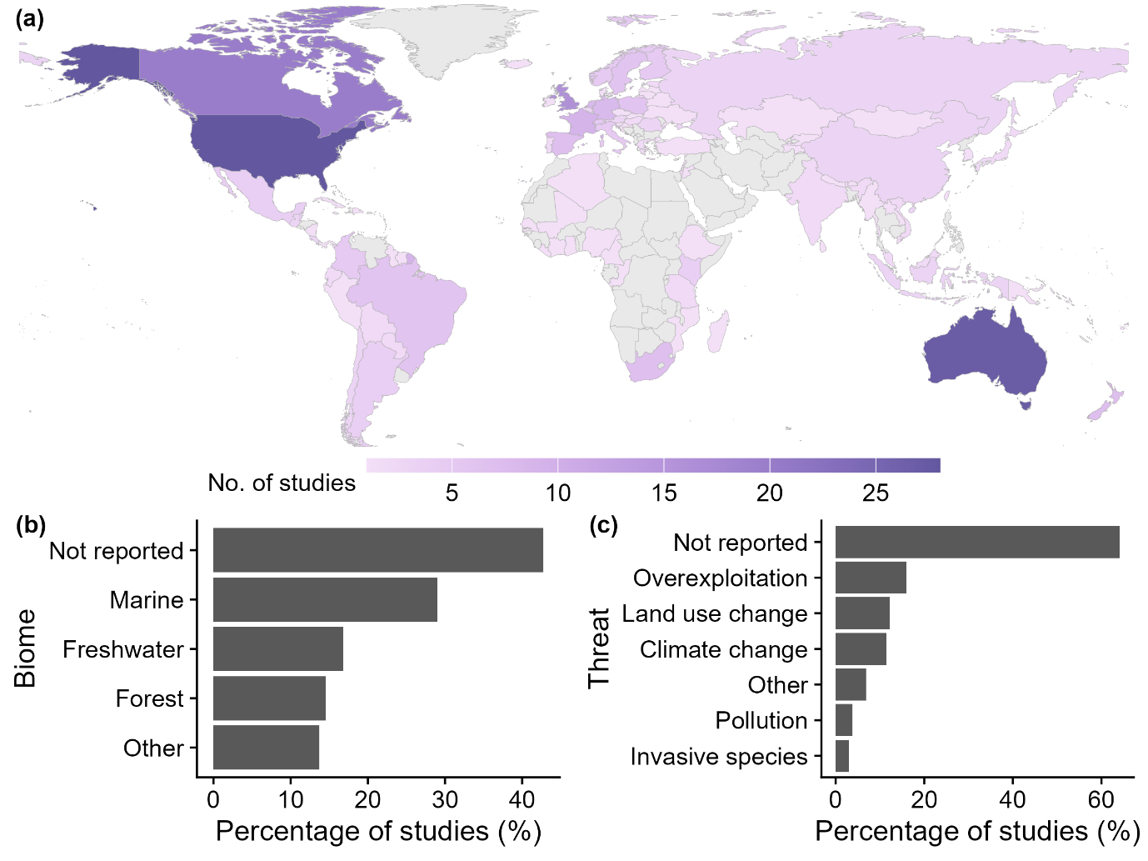
Figure 1 – The geographical, biome, and conservation context of studies: (a) the number of studies on factors impacting evidence use found in each country, light grey signifies no studies in a country; (b) the percentage of studies related to different broad biomes; (iii) the percentage of studies related to particular threats to biodiversity
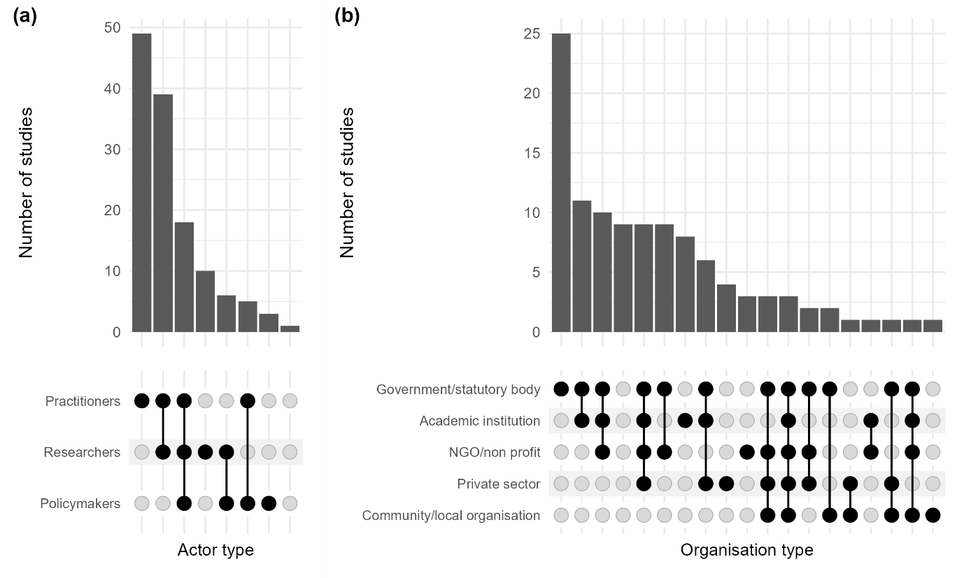
Figure 2 – The mix of (a) actors and (b) related organisations investigated in each study. In each figure the lower part represents the different mixes of actors/organisations studied, with a dark dot representing occasions where they have been studied and grey dots those where they have not.
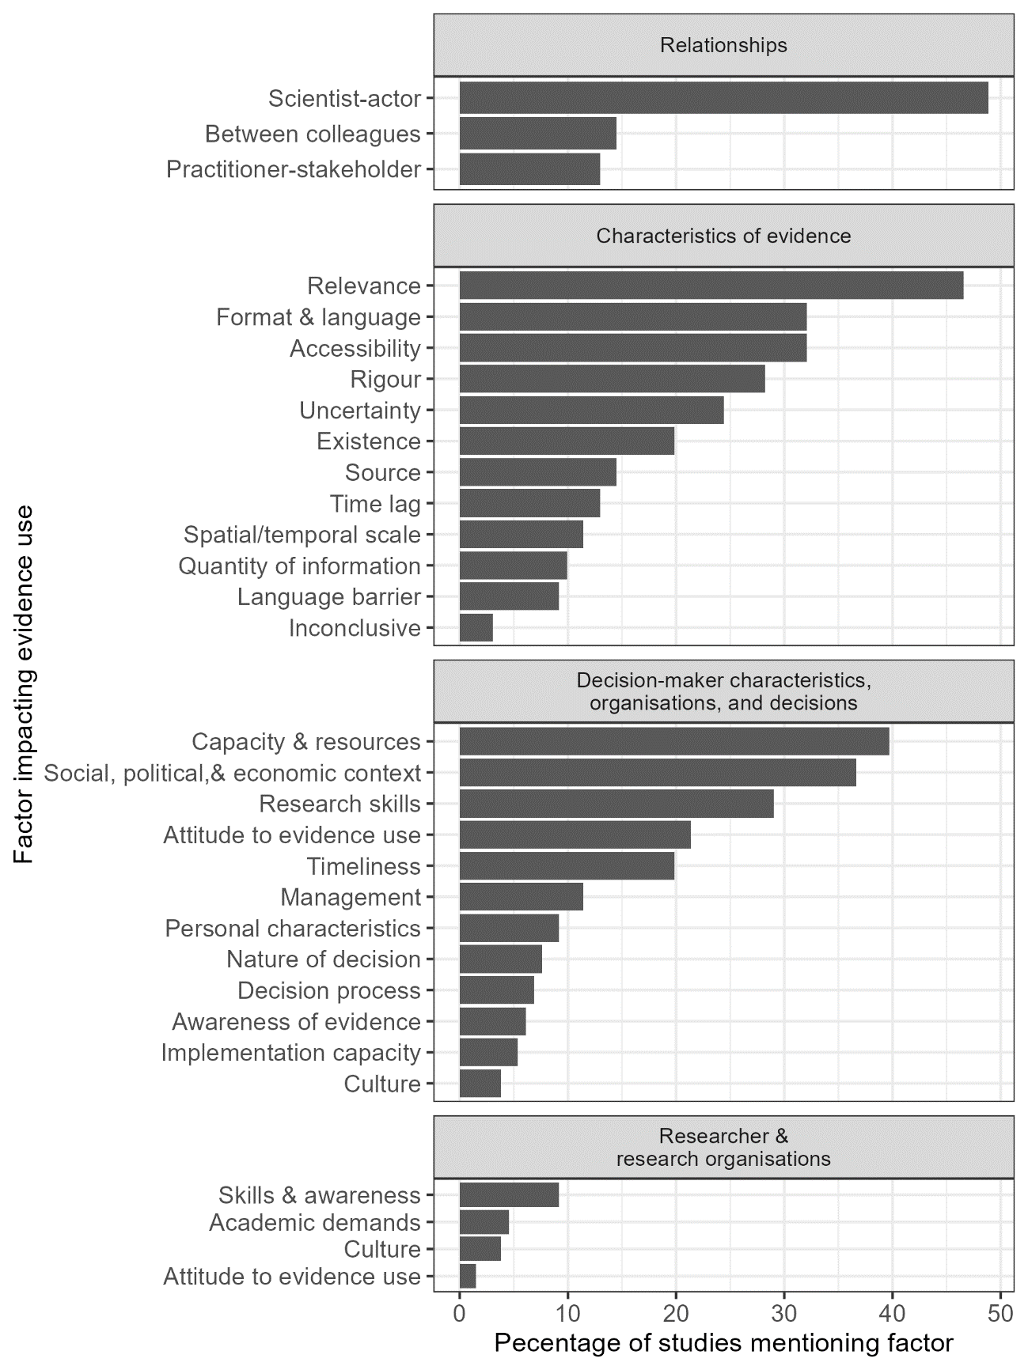
Figure 3 – The percentage of studies which mention individual factors that influence scientific evidence use in biodiversity conservation. Factors are divided into broad thematic categories to facilitate interpretation.
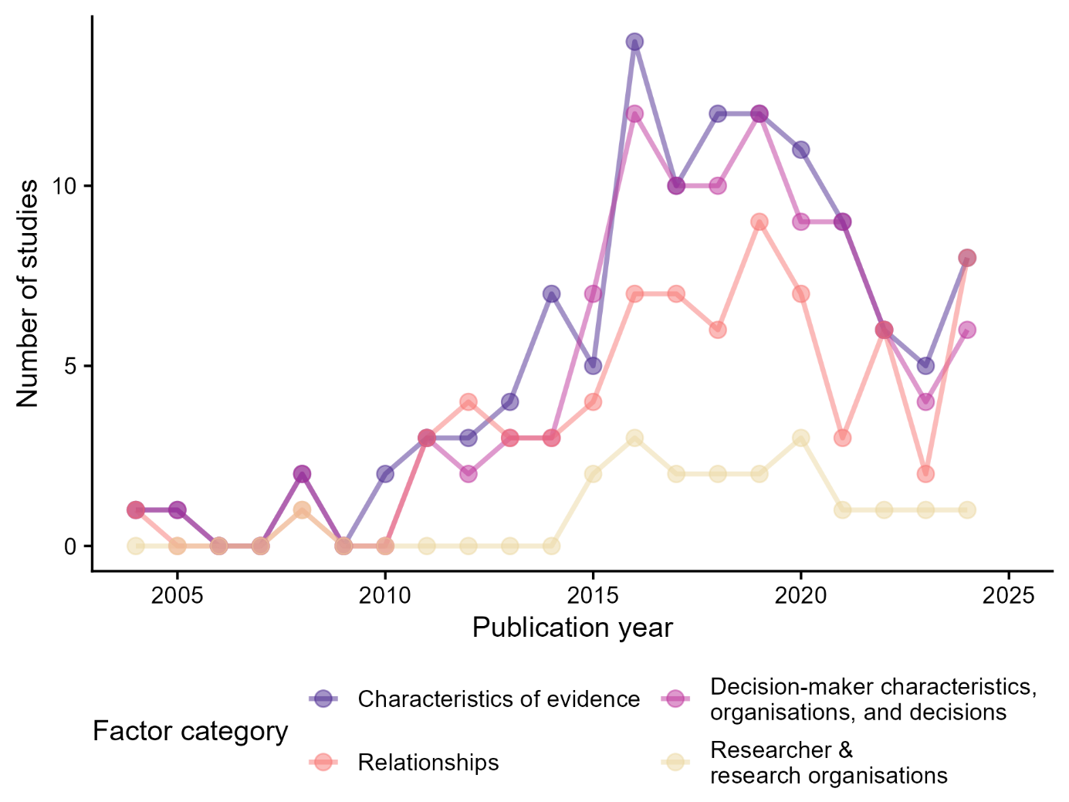
Figure 4 – Temporal changes in the frequency with which different broad categories of factors impacting scientific evidence use in conservation have been investigated

